 | Title | First Name | Last Name | Photograph
Name | DR. | PAVANBIR | KAUR | 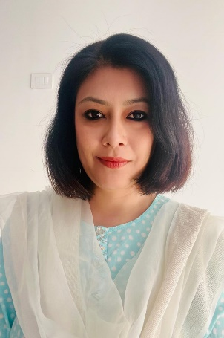
Designation | Assistant Professor
Educational Qualification | MA-English / MA-Psychology /Ph.D. (Eng. Lit)
Date of Joining | 01/07/2015
Department | ENGLISH
Address
Local | Kanchi Cottage, Salkavita, P.O New Rangia, Near Hebron School, Via NBU, Pin-734013, Dist-Darjeeling, WB
Permanent | Same As Above
Phone Numbers |  |  |  | PAN | ANZPK3608G
Office |  |  |  | Cell  Phone | 8617866215
Email | PAVANBIRKAUR@YAHOO.CO.IN
Fax
Teaching Experiences (Present & Previous) | 09 Years at Present and 06 years Previous
Research Interests | DIASPORA STUDIES
Research Guidance (PhD) | - - - -

Research Guidance (Master’s Theses) | - - - -
Awards
Professional Achievement | - - - -
ADMINISTRATIVE RESPONSIBILITIES | - Head Department of English: (July 2018 to June 2021)
SELECT LECTURES DELIVERED AT UGC REFRESHER COURSES/ICSSR RESEARCH METHODOLOGY COURSES

ICSSR Research Methodology Course Lectures | - - - -
UGC Refresher Course Lectures | • − − −
SELECT PUBLICATIONS
Some Major Research Articles In Journals | - − − −
Select Chapter’s in  Edited Volume | - - - -
Book Monograph/ Edited Book | BOOKS AUTHORED  • VALUE EDUCATION: A Practical Moral Science, (Co-authored Book 1 to Book 5), Timothy Publishing House, Gandhi Nagar, Siliguri  BOOKS EDITED- None  RESEARCH MONOGRAPHS: None
Project | • − − −
Book Reviews | BOOK REVIEWS  • ...........

PAPER PRESENTED IN SEMINARS/  CONFERENCES | None
- Select International Seminars/Conferences
- Select National/Regional/State Level Seminars and Conferences
RESOURCE PERSONSHIP / KEYNOTE ADDRESS
IN SEMINARS/ WORKSHOPS
 | - 2022: Participated as a Resource Person (Online) and delivered a Talk entitled “Resource Methodology” at the Workshop on Resource Methodology organized by the Department of Humanities, St. Claret College, Bengaluru held on 7 to 9 March, 2022.
Invited Lectures (UGC and University Invitations) | - - - -
UGC REFRESHER COURSES ATTENDED
 | - - - -
MEMBERSHIP OF PROFESSIONAL AND ACADEMIC BODIES
 | - - - -

