 | Title | First Name | Last Name | Photograph
Name | Mr. | Subham | Mandal | 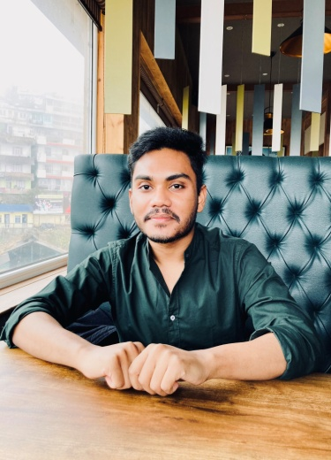
Designation | Asst. Professor
Educational  Qualification | M.A. (English)
Date of Joining | 01.09.2021
Department | English
Address
Local | Tulakata Jote, P.O. Kadamtala, Nivedita Sarani, Shivmandir, Dist. Darjeeling. Pin no. 734011
Permanent | Same as local address
Phone Numbers |  |  |  | Pan
Office |  |  |  | Cell Phone | 8116829663
Email | Mandalsubham996@gmail.com
Fax
Teaching Experiences | Asst. Teacher in Darjeeling Public School, Ranidanga (from 29th July 2019 to 31st August 2021)
Research Interests | Finished PhD Coursework from Dept. of English, University of North Bengal and doing research on Dystopia.
Research Guidance (PhD) | ---

Research Guidance
(Master’s Thesis)
Awards | - Recipient of the Silver medal from University of North Bengal for standing 1st Class 2nd in M.A. (English), 2019  - Awarded by English Language Lover’s Association (West Bengal)
Professional Achievement | ---
Administrative  Responsibilities | Member of Exam Cell
ICSSR Research Methodology Course Lectures | ---
UGC Refresher Course Lectures | ---
Select Publications:
Some Major Research Articles In Journals: | - Influence of Foucault's Biopower in Camus' The Stranger  - An Interpretation of Freud's Oedipus complex in The Sound and the Fury
Select Chapters In Edited Volumes: | 1. INTERPRETATION OF AMITAV GHOSH'S THE SHADOW LINES WITH NIETZSCHE'S WILL TO POWER  2. Interpretation of Nietzsche’s ‘will to power’ with Adichie’s Purple Hibiscus
Book Monograph/ Edited Book | ---
Project | ---
Book Reviews | ---
Paper Presented In Seminars And Conferences | - Violence through the ages in literature.
Resource Personship/ Keynote Address In Seminars/ Workshops | ---
Invited Lectures  (UGC And University Invitations) | ---
UGC Refreshers Courses Attended | ---
Membership Of Professional And Academic Bodies | ---

