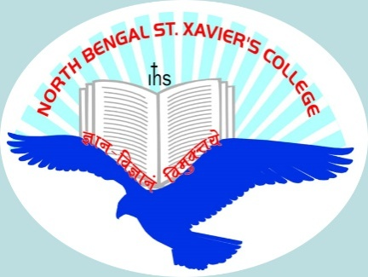

 |  | Title | First Name | Last Name | Photograph
Name |  | Ms. | Ambika | Chettri | 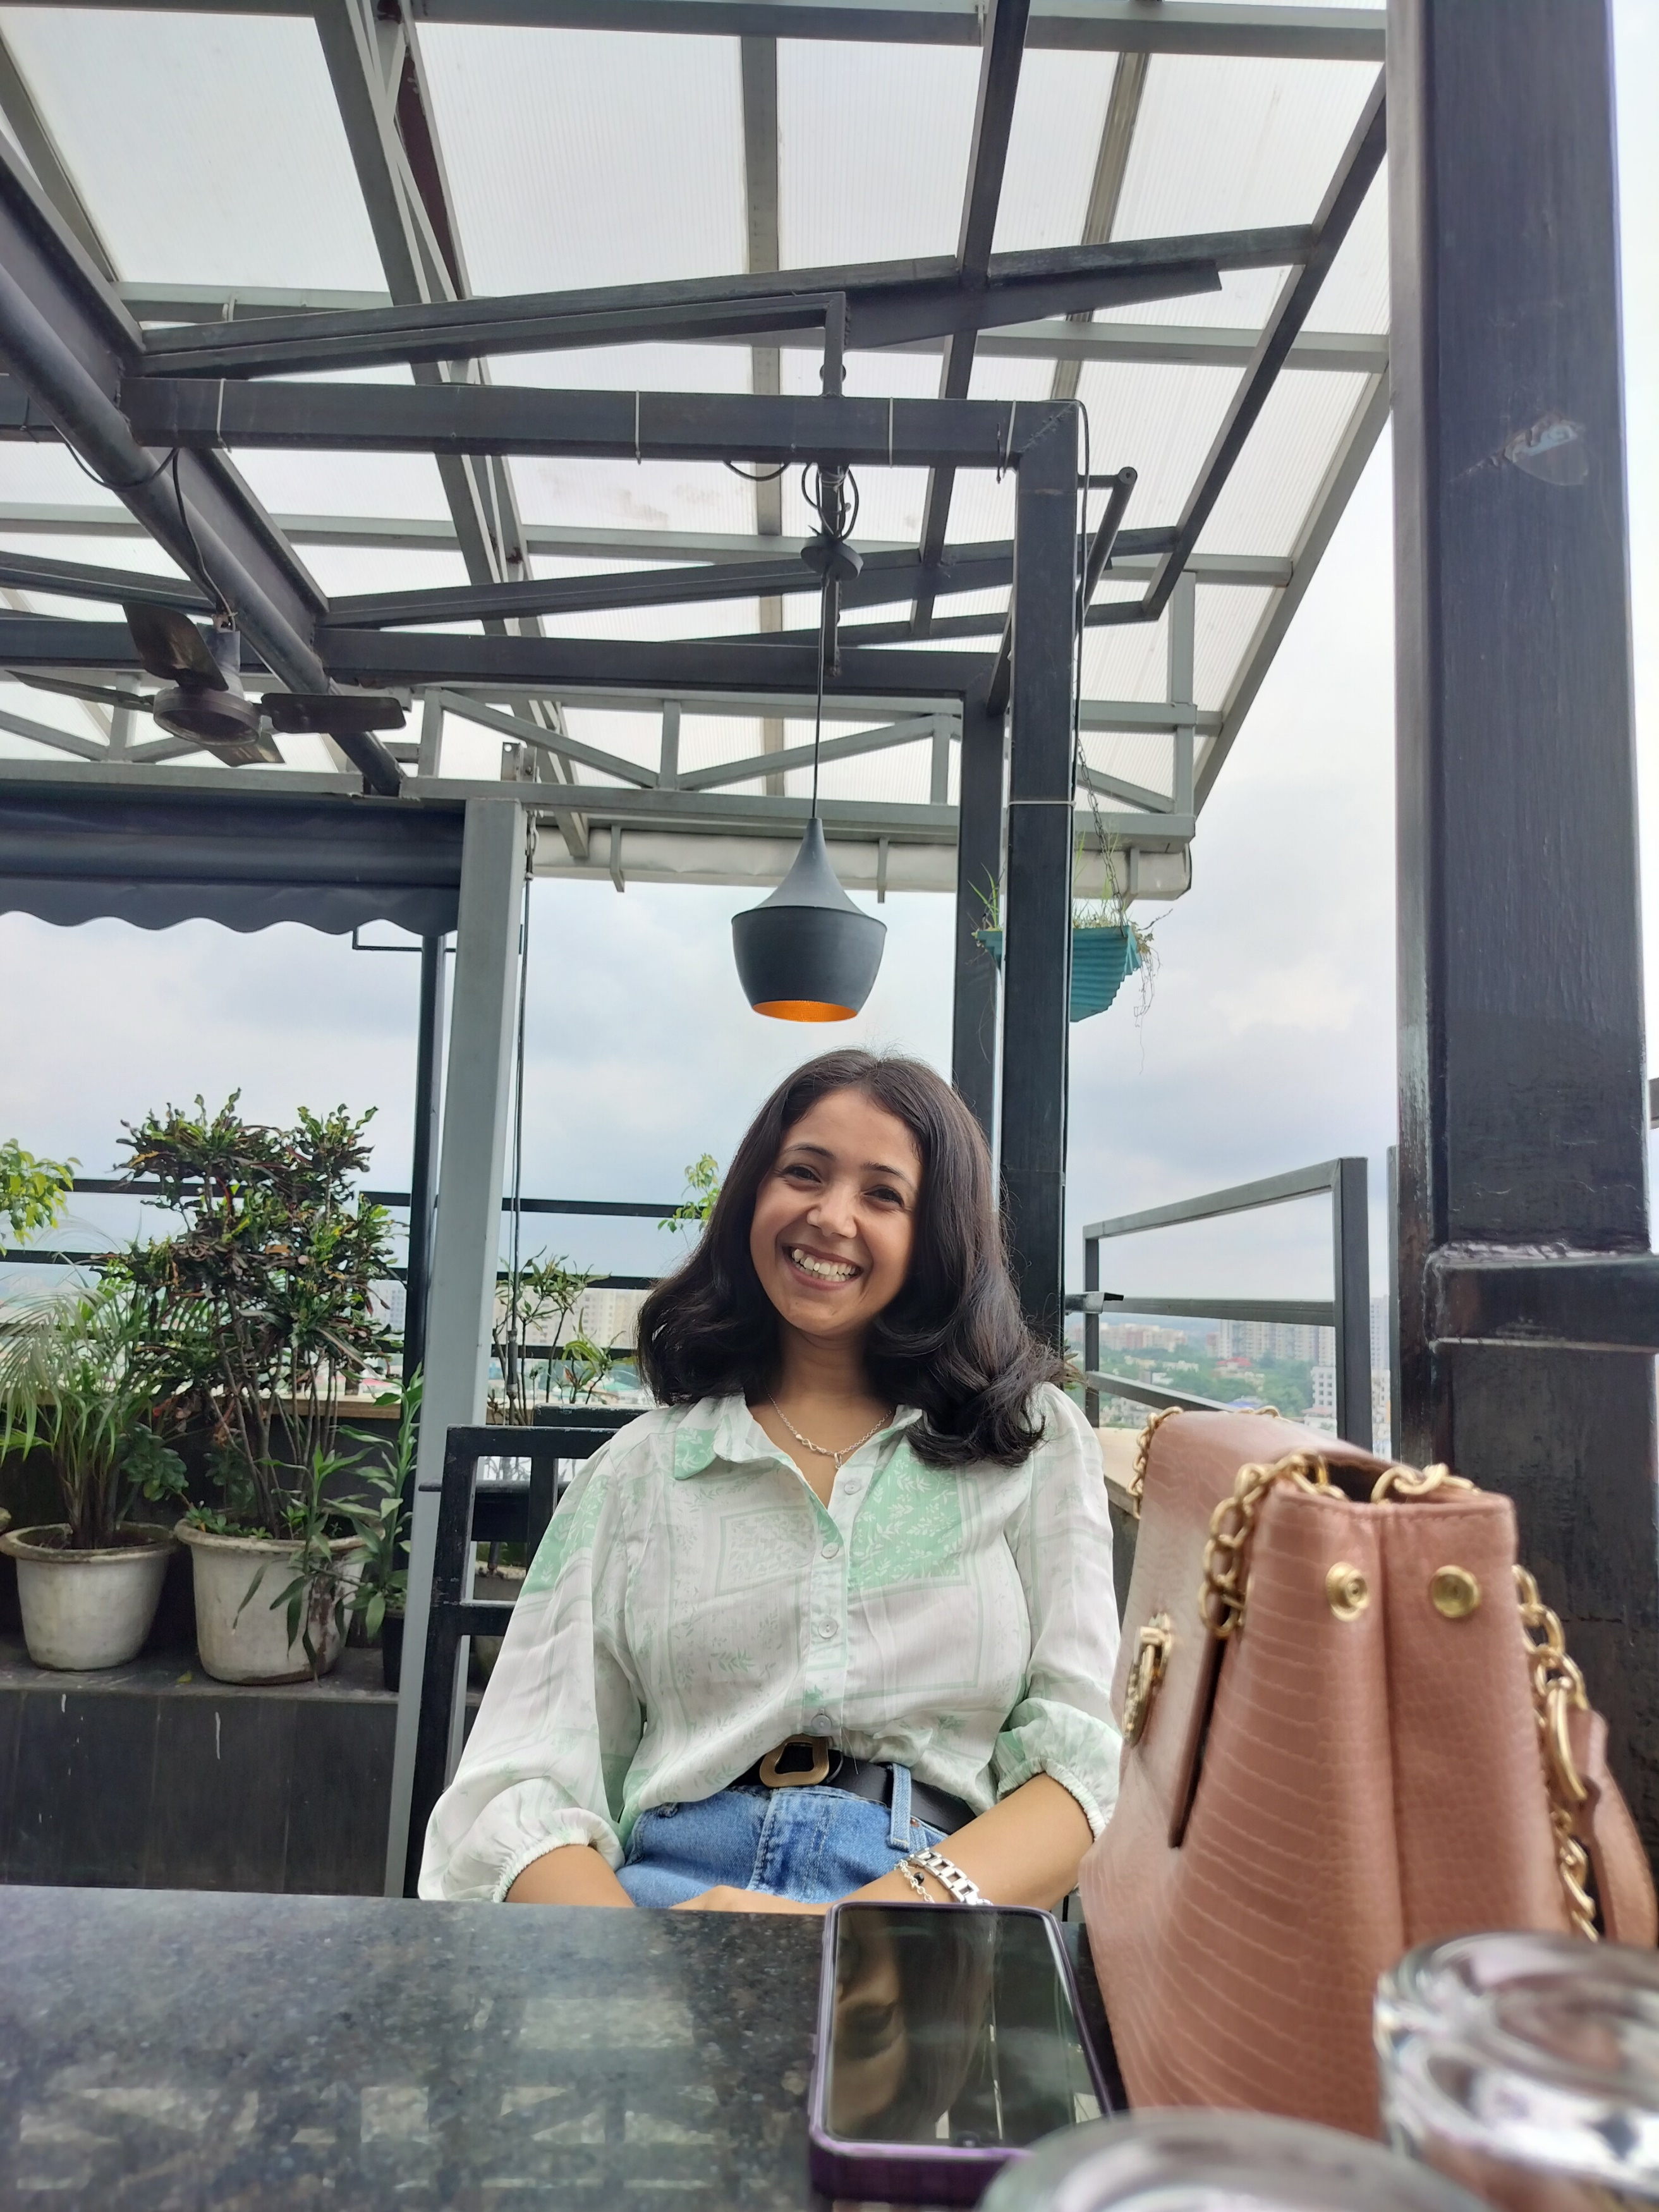
Designation |  | Assistant Professor
Educational Qualification |  | M.A, M. Phil.  UGC NET, WB SET
Date of Joining |  | 1st July 2019
Department |  | Political Science
Address
Local |  | Debidanga Bazar, Champasari- 734003
Permanent |  | Lower Harsing Hatta, P.O Lebong, Darjeeling-734105
Phone Numbers |  |  |  |  | PAN
Office |  | 9775514017
Email |  | Cambika938@gmail.com
Fax
Teaching Experiences  (Present & Previous) |  | Teaching in North Bengal St. Xavier’s College as Assistant Professor in the Department of Political Science since 2019.
Research Interests |  | Political Thought and Theory, Social Movements, Environmental Politics, Identity Politics.
Research Guidance
Awards
Professional Achievement
ADMINISTRATIVE RESPONSIBILITIES
SELECT LECTURES DELIVERED AT UGC REFRESHER COURSES/ICSSR RESEARCH METHODOLOGY COURSES
ICSSR Research Methodology Course Lectures
UGC Refresher Course Lectures
Some Major Research Articles In Journals
Select Chapter’s in Edited Volume
Book Monograph/ Edited Book
Project
Book Reviews
PAPER PRESENTED IN SEMINARS/ CONFERENCES |  | Paper presented on International Seminar organized by Department of Political Science and Bengali on Research Methodology in Social Sciences: Relevance of Ancient Indian Discourses in the Contemporary Context on the Topic Position of Women in Vedic and Post Vedic Literature, 22nd and 23rd March 2024.
PARTICIPATED IN SEMINARS/ CONFERENCES/RC/OP |  | Participated in 7 days workshop on Research Methodology organized by Centre for Women’s Studies, NBU from 21st March-27th March 2017.  Participated on 7 days workshop on Women’s Studies organized by Centre for Women’s Studies, NBU from 22nd March- 27th March 2017.  Participated on 7 day Workshop on Methodological Significance of Social Science Theories organized by the Department of Sociology and HRDC, NBU and RC 28: Sociology of Everyday Life of the Indian Sociological Society from 7-13th March 2022.
RESOURCE PERSONSHIP / KEYNOTE ADDRESS IN SEMINARS/ WORKSHOPS
Invited Lectures
(UGC and University Invitations)
MEMBERSHIP OF PROFESSIONAL AND ACADEMIC BODIES

